Summary Report

Round Table Meet on
“Management of Moderate to Severe Infective Exacerbations of Chronic Bronchitis in Outpatient Settings”
- Venue: Hotel Taj Corbett, Jim Corbett
- Date: 25th May’19

Scientific Chairpersons/Cordinator:
Dr Agam Vora
Dr S.K.Katiyar
Dr Suryakant Tripathy

Attendees:
Dr. S.K.PATHAK
Dr. SURYAKANT TRIPATHI
Dr. ANKIT DESHWAL
Dr. HARISH VAISHNOV
Dr. BRAJESH PRAJAPATI
Dr. MANOJ AGRAWAL
Dr. D.P.MISHRA
Dr. T.K.AGRAWAL
Dr. ASHISH JAISWAL
Dr. SANJEEV SUMAN
Dr. AWADESH VASHISTH
Dr. MANDEEP SINGH
Dr. GURAUNAK SINGH
Dr. K P SHIRVASTAVA
Dr. MANISH KUMAR
Dr. PUNEET AGARWAL
Dr. ANUPAM SINGH
Dr. R A S KUSHWAHA
Dr. ASHOK GUPTA
Dr. AMIT AGRAWAL
Dr. RAJAT AGRAWAL
Dr. HARENDRA YADAV
Dr. NEERAJ KUMAR
Dr. GUPREET NARULA
Dr. VEEROTTAM TOMAR

Objective:
To understand the infection pattern in Moderate to Severe AECB & COPD and also to get an insight about positioning Cefditoren in management of infectious AECB & COPD in OPD.
Special focus was given on 2 parameters:
- Time Interval to Next Exacerbation
- Eradication of Infection involving : Klebsiella, Streptococcus and other Respiratory pathogens

The Program Flow
25th May’19
Check in from 12 noon onwards
Time | Topic | Speaker
7:30 pm – 7:35 pm | Welcome | Dr Agam Vora
7:35 pm – 7:40 pm | Corporate Welcome | Mr. Alhad Mahajani
7:40 pm – 8:10 pm | Overview of AECB/COPD, Current issues and challenges | Dr S.K.Katiyar
8:10pm – 8: 40pm | Infectious AECB/COPD & Choice of antibiotics | Dr Agam Vora
8:40pm – 9: 10pm | Cefditoren : A newer Antibiotic in infectious AECB/COPD
9: 10pm onwards | “Breath Free” : A Grand Get-together

Details

A warm welcome extended by Zuventus to all the invitees amidst the amusing natural beauty of Jim Corbett at Hotel Taj Corbett on 25th May’19.
The evening of 25th May was made a special one by the brainstorming Round Table Discussion on “Management of Moderate to Severe Infective Exacerbations of Chronic Bronchitis in Outpatient Settings”.
The scientific session started sharp at 07:30 PM with a warm welcome by Dr Agam Vora on behalf of Academy of Advance Medical Education and Mr. Alhad Mahajani (VP-Marketing) on behalf of Zuventus.
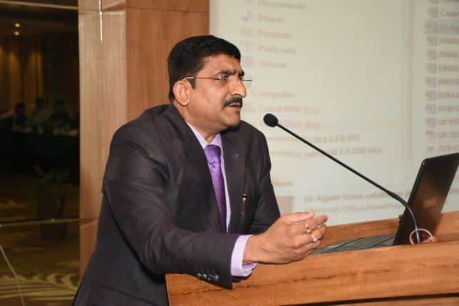
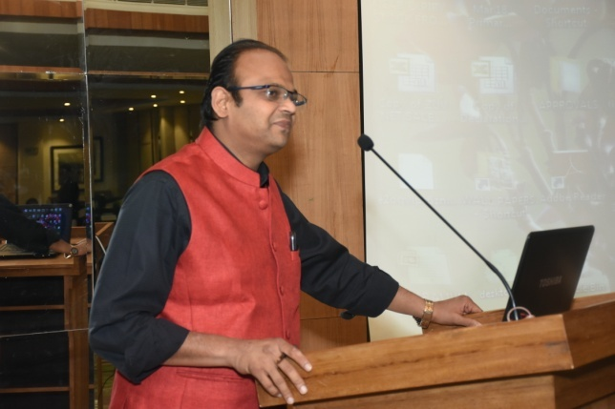

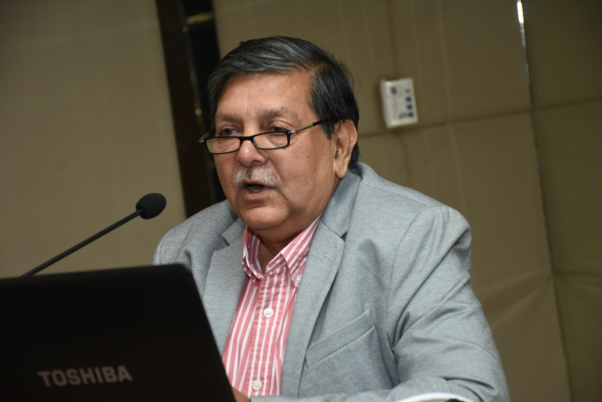
Scientific Chair, Dr S.K. Katiyar presented an overview of the subject and appropriateness of Cefditoren in AECB & COPD following which Dr Agam Vora put forward the current issues in managing infectious AECB & COPD in OPD and Choice of Antibiotic with special focus on Cefditoren as a choice of antibiotic.
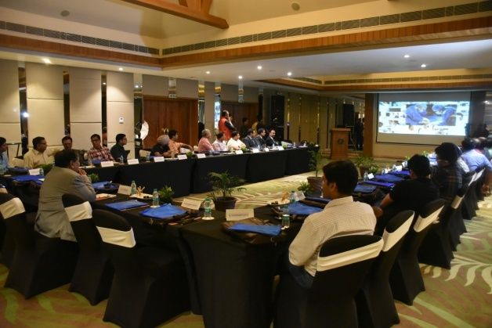
POINTS DISCUSSED IN ROUND TABLE MEET.
- Antibiotics must be used rationally in AECB/COPD cases. In most of the cases Antibiotics are required.

- Fluoroquinolones should not be used in AECB/COPD or any RTI cases (except in case of Beta lactam/Cephalosporin allergic patients).

- Macrolides are not effective against Streptococci, hence, not a choice in AECB/COPD.

- During panel discussion, emphasis was given on preferably not to use Levofloxacin in respiratory infections with exception of beta lactam allergy. Fatal Cardiac adverse effects associated with Levofloxacin & Severe hypokalemia with Azithromycin limits use of these antibiotics in co-morbid conditions.

- Cephalosporins are the best choice for AECB/COPD cases and looking at the wider spectrum and efficacy, wider beta lactamase stability – Cefditoren can be the appropriate choice of antibiotic in AECB/COPD.

- Depending on the severity of Infection Cefditoren can be used as 200 mg to 400 mg BID for 10 days in AECB/COPD.

Overall positive opinion about Cefditoren and the house agreed on the point that Levofloxacin should not be used in RTI including AECB & COPD & Azithromycin has no activity against S.pneumoniae
---------------------------------End of Report-----------------------------------------------

